C.O.A.C.H.E.D.

COACHED – a Mnemonic for Safe Defibrillation – generally used by ALS nurse and in ED
- Continue compressions (I won’t shock you)
- Oxygen away (only required to be removed if on free flowing BVM)
- All else clear
- Charging Defibrillator (200 joules)
- Hands off please
- Evaluate rhythm
- Defibrillate OR Dump Charge
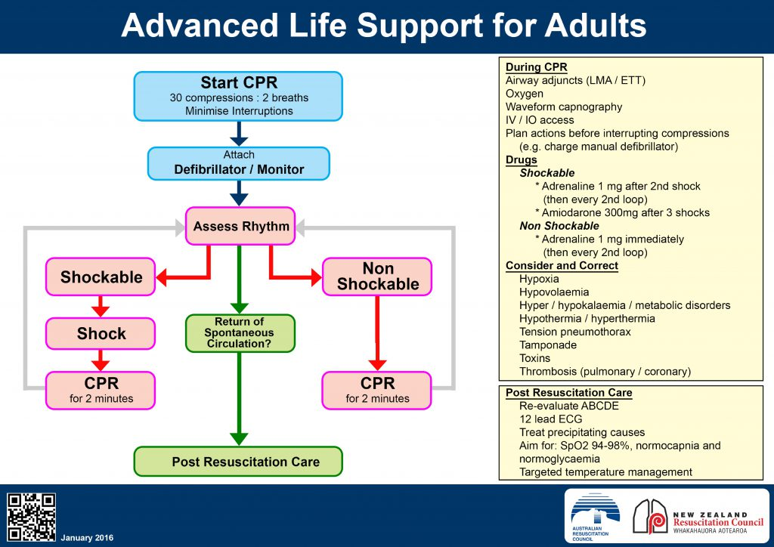
Post- resuscitation care (what to do after a successful resuscitation?)

Airway
- ?need for adjuncts/ intubation (anaesthetics pager 8460)
Breathing
- Maintain sats >94%- avoid hypoxia
- ABG
- Avoid hypercapnoea
- Assess differentials- ?PE/ pneumothorax
Circulation
- Maintain BP and Urine Output
  - IV fluids (cold v warn)
  - Metaraminol/Adrenaline judicious bolus/infusion
- 12 lead ECG and monitoring
- Assess other circulation problems that may have caused arrest - ?tamponade/ MI/ dissection
D
- Assess GCS and pupils
- Assess differentials ?SAH/ toxins
E
- Temperature ?hypo/hyperthermic
- ?therapeutic temperature management- avoid hyperthermia
F
- IVFs, how much? End points? IDC
G
- Maintain normoglycaemia

Management Options for ACUTE HYPERKALAEMIA (start with “IV, O2, and monitoring”)
