
Approach to Hypotension

Types of shock (differentiating signs and specific management)

- Hypovolaemic/ haemorrhagic
- Septic
- Anaphylactic
- Obstructive
- Cardiogenic
- Neurogenic

Airway
- Ensure patency
- Assess for signs of anaphylaxis
Breathing
- Maintain SpO2 >94%
- Assess for sepsis, tension pneumothorax, PE, APO
Circulation
- Assess HR
  - Is HR the cause or the result of the hypotension
- Assess peripheries
  - Warm v cold shock
- Assess JVP
  - Flat v distended
Disability
- Assess GCS or “AVPU”
  - Good marker of perfusion
  - ?intracranial sepsis
Exposure
- Assess temp
- Seek source of
  - Bleeding (bedside beta-HCG in all women of childbearing age)
  - Sepsis
  - Allergens (anaphylaxis)
Fluids

- Judicious boluses of IVT
- Assess volume status
  - ‘Dry’ v ‘overloaded’
- What is the role of ultrasound?
- If not fluid responsive - various ‘vasopressor’ or ‘ionotrope’ choices

Glucose

Anaphylaxis

In order to recognise anaphylaxis you need to have a high index of suspicion where you see a combination of classic signs and symptoms.

There are 5 systems to consider:
- Cardiovascular (hypotension and tachycardia)
- Respiratory (wheeze)
- Skin (rash) and Mucous Membrane (swelling and sore throat)
- Gastrointestinal (nausea and vomiting)
- Neurological (Anxiety and Loss of Consciousness)

‘ Anaphylaxis is likely if two of the above systems are involved in an acute ‘allergic reaction’ ’

What are your Initial Actions?

• Adrenaline should be given as soon as possible intramuscular (IM) injection (not IV unless extremis)
• The dose is 0.5mg (or an “EpiPen®” 0.3mg). It should be given IM and repeat every 3 - 5 minutes.
• Local Guidelines – http://www.resus.org.au/policy/guidelines/section_9/guideline-9-2-7-july12.pdf
• Remove the precipitating cause (e.g. bee sting, blood transfusion, medications, offending food)
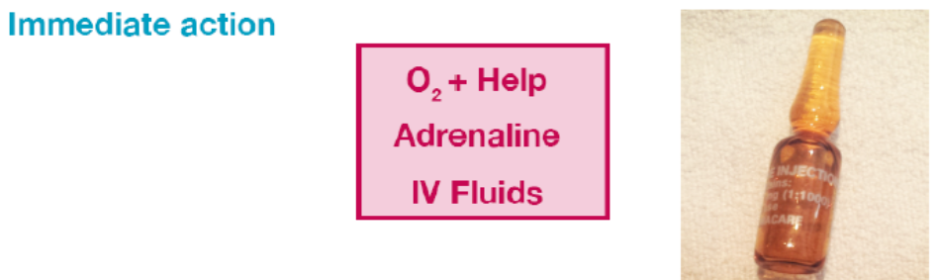

‘Unexplained Hypotnesion?’ – A checklist for any patient:
