Answers
Cardio SAQ
(online)

QUESTION 1
A 65 year old man presents to the emergency department with a history of palpitations. (10 marks)
The vital signs are:
BP | 105/60 | mmHg
HR | 156 | beats/min
RR | 26 | /min
Temperature | 36.2 | ºC
(His ECG is on page 4)
- List three (3) ECG abnormalities to support the diagnosis of Ventricular Tachycardia. (3 marks)

- ANY BRUGADA CRITERIA ON ECG - https://litfl.com/vt-versus-svt-ecg-library/
- Broad complex tachycardia at rate ~ 150 beats/min
- Extreme axis deviation (polar, north-west)
- ? (possible) Presence of a fusion beat
- List four (4) important ‘clinical features’ that would influence your decision to perform early electrical cardioversion for this patient. (4 marks)

- ARC / international list varies:
  - Hypotension
  - SP <90mmHg
  - Altered mental status/confusion
  - New onset chest pain / cardiac chest pain / angina
  - Loss of consciousness
- Other signs of ‘shock’
- Assuming no ‘red-flags’ or signs of ‘instability’ are found on your initial assessment, list three (3) choices for chemical cardioversion, specifying intervention and doses. (3 marks)
 | Intervention (drug) | Dosing and Route
1 | Amiodarone | 150-300mg IV over 15-30 mins  900mg over 24 hours IV
2 | Others  - Sotalol (not available IV in Aus)  - Magnesium | various
3 | Current  - Lignocaine | 1mg/kg

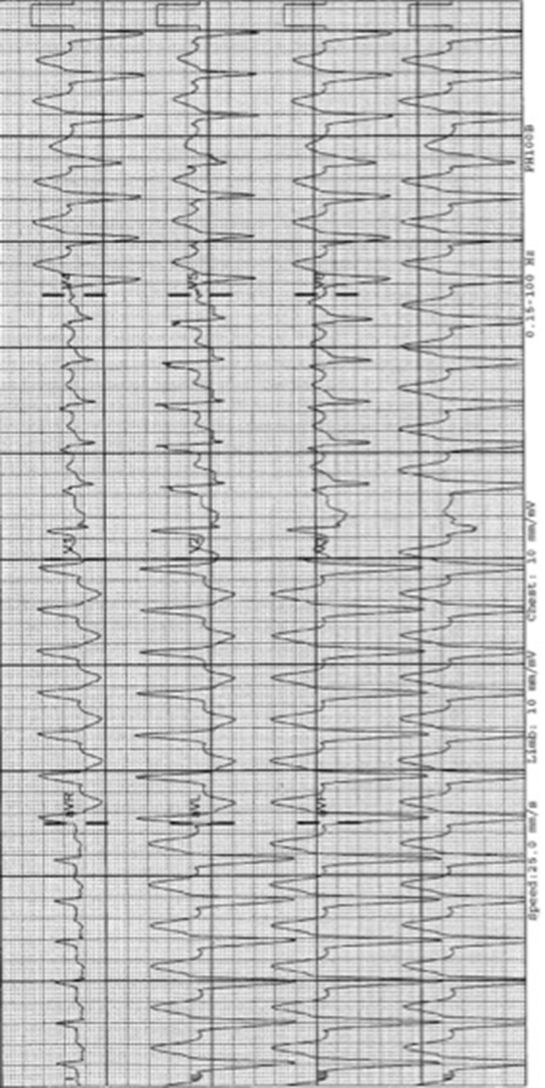
QUESTION 2
A 32 year old woman is brought to your emergency department from a shopping centre where she had a witnessed episode of “collapse”. On examination there is no evidence to suggest traumatic injuries. (18 marks)
- List four (4) critical diagnoses you would consider a priority to exclude. Additionally, list the features (one (1) risk factor and one (1) symptom) that would support each of the differential diagnoses. (12 marks)
 | Diagnosis | Risk Factor |  | Symptom
MUST SAY ECTOPIC
Consider reviewing - https://www.youtube.com/watch?v=t1KuAtx7gmE
1 | Malignant Arrhythmia eg VT |  | Family history of sudden cardiac death | Palpitations
2 | Pulmonary embolism |  | Exogenous oestrogens | Pleuritic chest pain
3 | (LESS LIKLEY)  Aortic dissection |  | Marfan’s syndrome | Sudden onset chest pain preceding collapse
4 | Sepsis |  | Current infection/immunocompromise | Fever/sweats
 | Hypoglycaemia not accepted
- List and justify three (3) immediate BEDSIDE investigations that you would prioritise (6 marks).
 | Investigation | Justification
 | MUST SAY HCG (In some form) | – ectopic rule out
1 | ECG | Quick evidence for arrhythmia, ischaemia, Wolfe-Parkinson-White, Brugada syndrome, Long QT
2 | ECHO | Evidence of tamponade, potential to rule in dissection if flap seen, evidence of PE
3 | Venous/arterial blood gas | Detect lactate, electrolyte abnormalities, if arterial gas A-a gradient
Postural BP not accepted
CTPA / CTA considered
QUESTION 3
A 67-year-old lady presents to the Emergency Department (ED) with a history of increasing Shortness of Breath over the last 2 days. She is brought in by ambulance and was given an anti-emetic on route.
She has a past medical history of Diabetes Mellitus, Lung Cancer (NSCLC) and Hypertension (12 marks)
- Observations:

Blood Pressure 79/60 Respiratory Rate 20/min
Heart Rate 115 Temperature 37.4 ºC
Oxygen Saturations 100% (on 6 litres by Hudson Mask)
- State one (1) ‘physiological mechanism of action’ of a judicious fluid bolus of improving perfusion in a shocked patient (1 mark)
Increased volume in RA from increase venous return = in a non-failing heart increased contractility and increased CO

- List two (2) findings on an arterial blood gas that would suggest a ‘shocked state’. (2 marks).
1) Elevated lactate >2 mmol/L (range 2-4 – ideal cut point likely 2.5)
2) Metabolic acidosis, with pH < 7.25
3) base excess<-6 (range 5-9)
(various cut points in the literature – any two of above)
(iii) List four (4) key findings on the patient’s Electrocardiogram (shown on page 8). (4 marks).
- Low voltage complexes (ideally need to define)
- Sinus tachycardia about 115 beats/min
- Electrical alternans
- T wave inversions
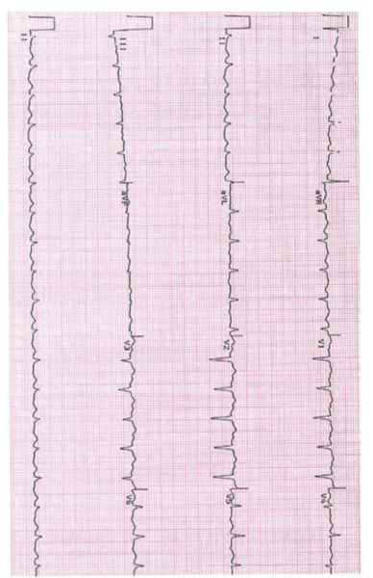
State the two (2) MOST likely differential diagnoses to account for this patient’s presentation (2 marks)
- Cardiac tamponade (pericardial effusion)
- Acute Pulmonary embolism
Other acceptable - sepsis
List three (3) other important differential diagnoses to account for this patient’s presentation (3 marks)
- Sepsis/pneumonia (or other)
- Acute Pulmonary Oedema
- Acute MI
- Bleeding / Anaemia
- Hyperviscosity / Paraneoplastic Sx could also cause SOB

QUESTION 4
A 66-year-old man with heavy smoking history and a diagnosis of COPD presents with shortness of breath and palpitations. He has had an increasing cough and sore throat over the last 2 days. (11 marks).
Medications include Tiotropium, Seretide and Salbutamol. The patient is not on home oxygen.
- Observations:
Blood Pressure 110/70 Respiratory Rate 25/min
Heart Rate 120 (irregular) Temperature 37.7 ºC
Oxygen Saturations 91% (on Room Air)
- List two (2) long term management strategies that have been shown to improve outcomes in adult patients with COPD (2 marks)
- Smoking cessation
- Pulmonary rehab
- Home o2
- ½ mark for Combination steroid and long acting beta agonist therapy
- State one (1) unifying diagnosis for the appearances on this ECG. (1 mark).
- Multifocal Atrial Tachycardia (MFAT)
- List four (4) key features seen on this patient’s 12 lead ECG. (4 marks).
- Multifocal P waves (at least 3 different morphologies)
  - and irregularly irregular rhythm
- Right Axis deviation
- Right Bundle branch block (partial)
- ST depression in I, V4-6
ECG (page 11)
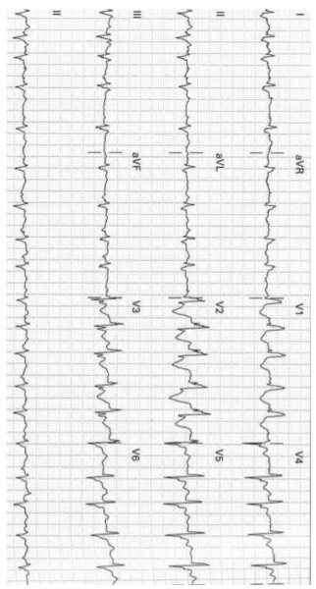

- List 5 differential diagnoses for this patient’s presentation and ECG findings. (5 marks).
- COPD Exacervation
- Asthma
- Med toxicity (salbutamol, theophylline)
- OTHERS:
- Primary Pulmonary hypertension
- Cor pulmonale
- Pulmonary embolism
- Interstitial pneumonia
- Left ventricular failure / Acute MI

QUESTION 5
You are the only consultant working a busy evening shift in emergency department when the triage nurse tells you that 19 patients have self-presented to triage in the last five minutes with having ingested a large quantity of “oleander tea” as part of a game at a music festival.
An ambulance has turned up with the first of sixteen patients from the festival complaining of palpitations.
- List five (5) further pieces of pertinent information that you ask the ambulance officer for in regards to the overall situation at the festival? (5 marks).
- METHANE
(ii) State the antidote(s) your would seek to obtain to manage patients presenting to toxicity form the ‘tea’ (1 mark)
DIGBIND / DIGIFAB
II) Prior to managing the other 15 individual patients, list four (4) key steps do you take to:
  - Prepare your whole emergency department for this situation? (4 marks)
- Staff – brief team on expected presentations, management, complications
- Stuff – prepare rooms with ECG, resus equipment, drugs, lines etc
- Patients – expedite transfer to ward for those awaiting transfer and stable
- Clerical – enact disaster registration process, prepare them to handle relatives, expect media contact
  - Prepare the ‘whole’ hospital for this situation? (4 marks)
- Inform executive
- Major incident plan – appropriate administration, media, senior specialist involvement to prepare for lots of admissions to one service
- Stakeholders = Inform ICU as some patients may need to go there
- Inform pharmacy as likely to need more meds compared to usual demand
QUESTION 6
It is 2030 hours on a weeknight. You are the duty doctor in a tertiary level emergency department. (15 marks).
- The department currently has all cubicles occupied except for two which are ‘unmonitored’ spaces.
- Ambulance control rings to notify you that an ambulance is en route to your department with a 54 year old man with a probable acute myocardial infarct. Estimated time of arrival is 5 minutes.
All five of your resuscitation cubicles are occupied by the following patients:
- A 75 year old lady with unstable angina. She is awaiting a bed in the cardiology unit.
- A 50 year old man with resolved chest pain and normal ECG. He has just arrived by ambulance and is yet to be assessed.
- A 3 year old girl with croup. She is now stable 30 minutes after nebulised adrenaline.
- A 22 year old man being monitored 2 hours following an overdose of the drug Carbamazepine.
- A 17 year old man with a closed head injury. He is about to be intubated by your registrar because his GCS has fallen to 9/15.
- List three (3) immediate steps you will take to prepare to accommodate this patient. (3 marks).
- Notify N U M and make team plan for bedstate
  - Move child to a monitored room to continue treatment
  - Delegate calls CCU to expedite transfer of 75 yr old lady
  - Clarify plan for transfer of the head injured patient to ICU post CT
- The patient arrives and an ECG (shown on page 16) is taken:
  - State three (3) pertinent findings on the patient’s ECG (3 marks)
- Inferior ST elevation (II, III, avF with III > II)
- Rapid AF (need to say or lose one mark)
- Reciprocal changes
- Deep ST depression in V2-4 suggesting posterior involvement
- ST elevation also in V6

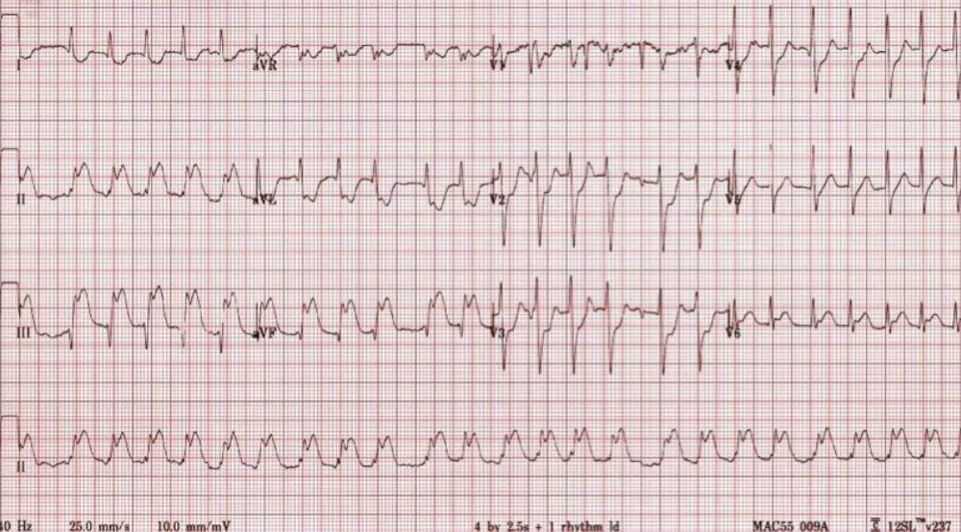The patient now has a short run of non-sustained VT on telemetry…
- List three (3) antiarrhythmic drugs that could be used at this stage. Specify the drug, dose and 1 pro/con for each (9 marks)
Drug | Dose | Pro | Con
1  Amiodarone | 150mg IV over 15-30 mins | Can be repeated  Multiple effects (receptors)  Well tolerated | Many  Side effects  Can’t do EPS  Blocks AV node
2  Magnesium | 2.47 grams IV over 20 min  Or 10-20 mmol 10-30 mins | Low risks of side effects/toxicity | May not be effective in absence of electrolyte abnormalities  Hypotension  Bradycardia
3  Procainamide (NZ only)  OR Lignocaine | 1mg /kg | Best evidence to support its use (recent papers of VT in contact of MI) | Risk of interaction/toxicity in presence of similar meds

QUESTION 7
A 32 year old female is brought to your ED by ambulance with a suspected drug overdose.
Her ECG on arrival is shown on the next page.
- Her observations are as follows:
BP 75/60
HR 140
Sats 94% on Non re-breather mask
Resp Rate 10
GCS 14/15

- List four (4) abnormalities on the ECG and state the (1) most likely cause (4 marks)
- Very broad QRD complexes
- Bizarre broad based T waves
- No clear P waves
- Tachycardia >120 beats/min
MOST LIKELY CAUSE: Tricyclic Antidepressant toxicity (Na blockade)

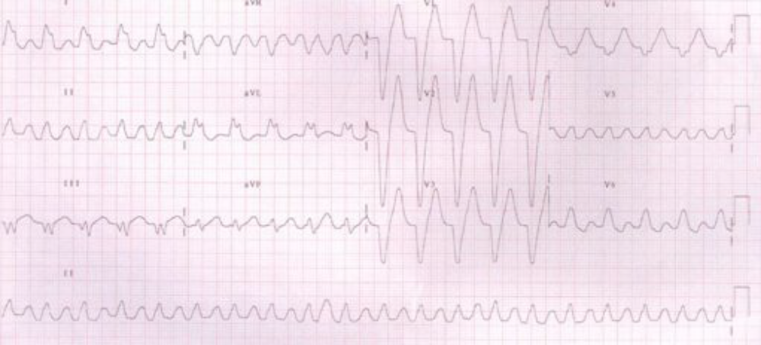

- The patient’s partner reveals she has taken >40 of her “prescribed antidepressant tablet”.
List your six (6) MOST important priorities in the initial management for this patient in the ED (6 marks)
- Give Hco3 (100mmol) over 5-20 mins - bicarbonate to decrease QRS duration (MUST SAY)
- Manage hypotension – temporise with bolus IV fluids, push-dose pressors e.g. metaraminol
- Sedate / intubate once optimised to protect airway and allow administration of activated charcoal if advised by tox and no ileus
- Pre-oxygenate with Non rebreathe mask at 15L/min and nasal prongs high flow
- Once intubated NG tube and consider 1g/kg or 50g activated charcoal
- Disposition – ICU / Consultation

Limited role for other meds (intra lipid, HDIE)

QUESTION 8
A 6 month old child is found by his parents to by cyanosed and unresponsive in their cot. She is brought to the ED where she dies despite extensive resuscitation. (12 marks).

The parents are anxiously awaiting the outcome in the family room.

- List BOTH how you would estimate AND your estimate the following factors for a Paediatric patient suffering a Cardiac Arrest in the ED

    - Weight (Age in yrs +4) x 2 7kg (accept 6-9) (1 mark)

    - Defibrillation Joules 4J/kg 25J-30J (1 mark)

    - Endotracheal Tube Size(s) (Age/4) +4 4.5 (1 mark)

    - Fluid Bolus 20ml/kg normal saline 120-160ml (1 mark)

    - Glucose 10 percent 2-2.5ml/kg 10% dextrose 12-18ml (1 mark)

    - Adrenaline cardiac arrest 0.1ml/kg 1:10,000 0.7ml (1 mark)

- State the MOST likely cause of the child’s untimely death. (1 mark).

- SIDS / SCA

- List five (5) other possible causes to account for the child’s untimely death. (5 marks).
THEMISFITS
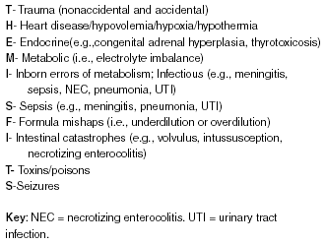

QUESTION 9
A 48-year-old man presents to the Emergency Department (ED) with a history of Cardiac Arrest at the local supermarket. CPR was started by bystanders immediately. (13 marks).
He received 2 DC Shocks by the ambulance paramedics and has a Return of Spontaneous Circulation (ROSC) prior to arrival in the ED

- The Current Neurological Status – “GCS 6 / pupils equal and reactive”

- ED Observations:

Blood Pressure 80/50 Respiratory Rate 15/min (spontaneous)
Heart Rate 75 Temperature 36.1 ºC
Oxygen Saturations 99% (on 10 litres by Hudson Mask)
(The ECG is shown on page 23)

- List three (3) the abnormalities on this patient’s Electrocardiogram. (3 marks)
- ST elevation with established ‘tombstone’ / concave morphology in anteroseptal leads (V1-5)
- Reciprocal changes suggesting acute MI
- Irregular rhythm, sinus pauses

- State six (6) possible differentials to account for ST elevation on ‘any patient’ with this finding. (6 marks)
- HARD TO GET 6 (liberal marking): -remember most ST E is not MI
- Myocardial Infarction
- LV aneurysm
- PERICARDITIS / Dressler’s
- BER
- LVH
- Other:
- Brugada syndrome
- Hyperkalaemia
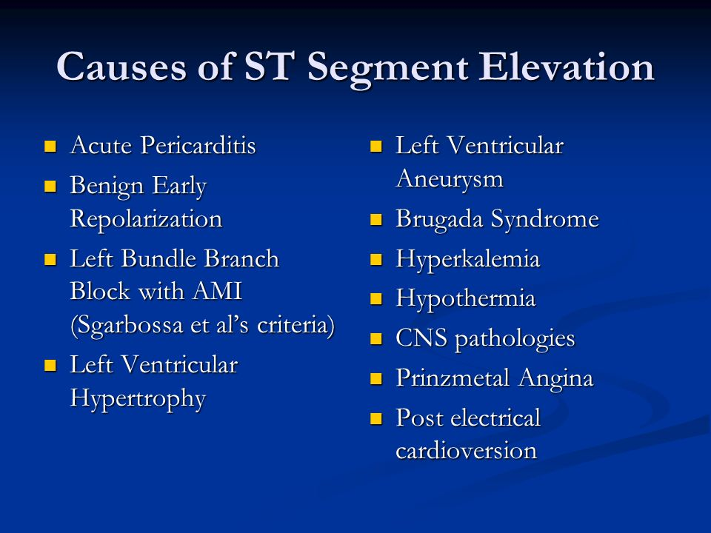
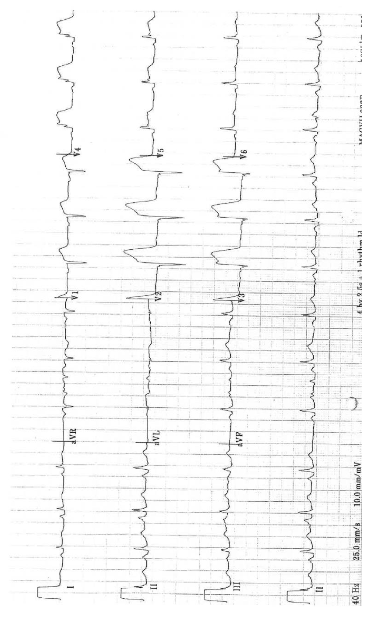
c) State four (4) immediate management priorities after a ROSC (post cardiac arrest) in a patient who remains unconscious following a VF arrest. (4 marks).
- Repeat ECG (serial)
- Monitoring
- Reassessment of A to G
- BSL Mx
- Avoid Hyperoxia
- Reperfusion therapy (PCI / thrombolysis)
- Targeted temperature management – prevent fevers by aiming for circa 36
- Prevent malignant arrhythmias by optimising electrolytes and myocardial stability

QUESTION 10
A 2 month old infant presents ‘unwell’ to ED with irritability and poor feeding. (11 marks)
Her ECG is shown below:
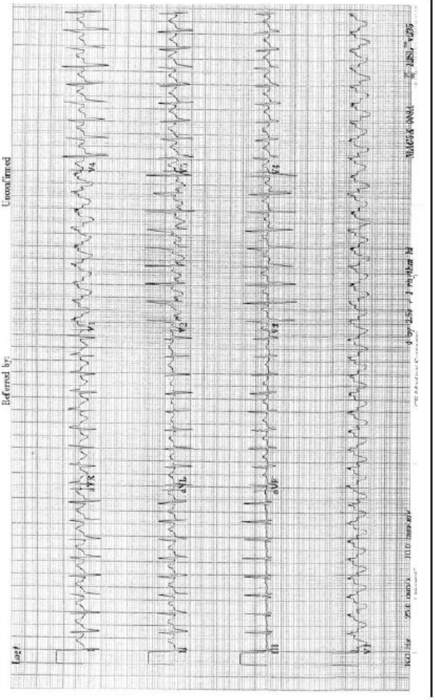
(I) Fill in the table below regarding three (3) findings on the ECG and state three (3) differentials. (6 marks).
ECG finding | Your comment(s) | Differentials (causes)
T waves | Inverted V1-2 | Normal for age  Rate related ischaemia  SVT  Sinus Tachy  More likely to be SVT if no variation over time  SVT v sinus tachy
Regularity | Regular
Rate | 200 +

(ii) Outline five (5) KEY steps your initial management in the ED. (5 marks).
- Monitor / team
- IV fluids
- 2x Access
- Valsalva manoeuvres / water immersion
- Slow rate – adenosine (FAIL QUESTION IF SAY CA BLOCKER)
- Get further expert help if not improving after above
  - Consider WPW / Consider underlying / undiagnosed cardiac issue (tetralogy etc.)
  - Consider tox causes

