
Approach to Hypotension

Types of shock (differentiating signs and specific management)

- Hypovolaemic/ haemorrhagic
- Septic
- Anaphylactic
- Obstructive
- Cardiogenic
- Neurogenic

Airway
- Ensure patency
- Assess for signs of anaphylaxis
Breathing
- Maintain SpO2 >94%
- Assess for sepsis, tension pneumothorax, PE, APO
Circulation
- Assess HR
  - Is HR the cause or the result of the hypotension
- Assess peripheries
  - Warm v cold shock
- Assess JVP
  - Flat v distended
Disability
- Assess GCS
  - Good marker of perfusion
  - ?intracranial sepsis
Exposure
- Assess temp
- Seek source of
  - Bleeding (bedside bHCG)
  - Sepsis
  - Allergen
Fluids

- Judicious boluses
- Assess volume status
  - Dry v overloaded
- Role of USS
- If not fluid responsive- ionotrope choice

Glucose

An Approach to life-threatening bleeding and transfusions (blood bank 57700)
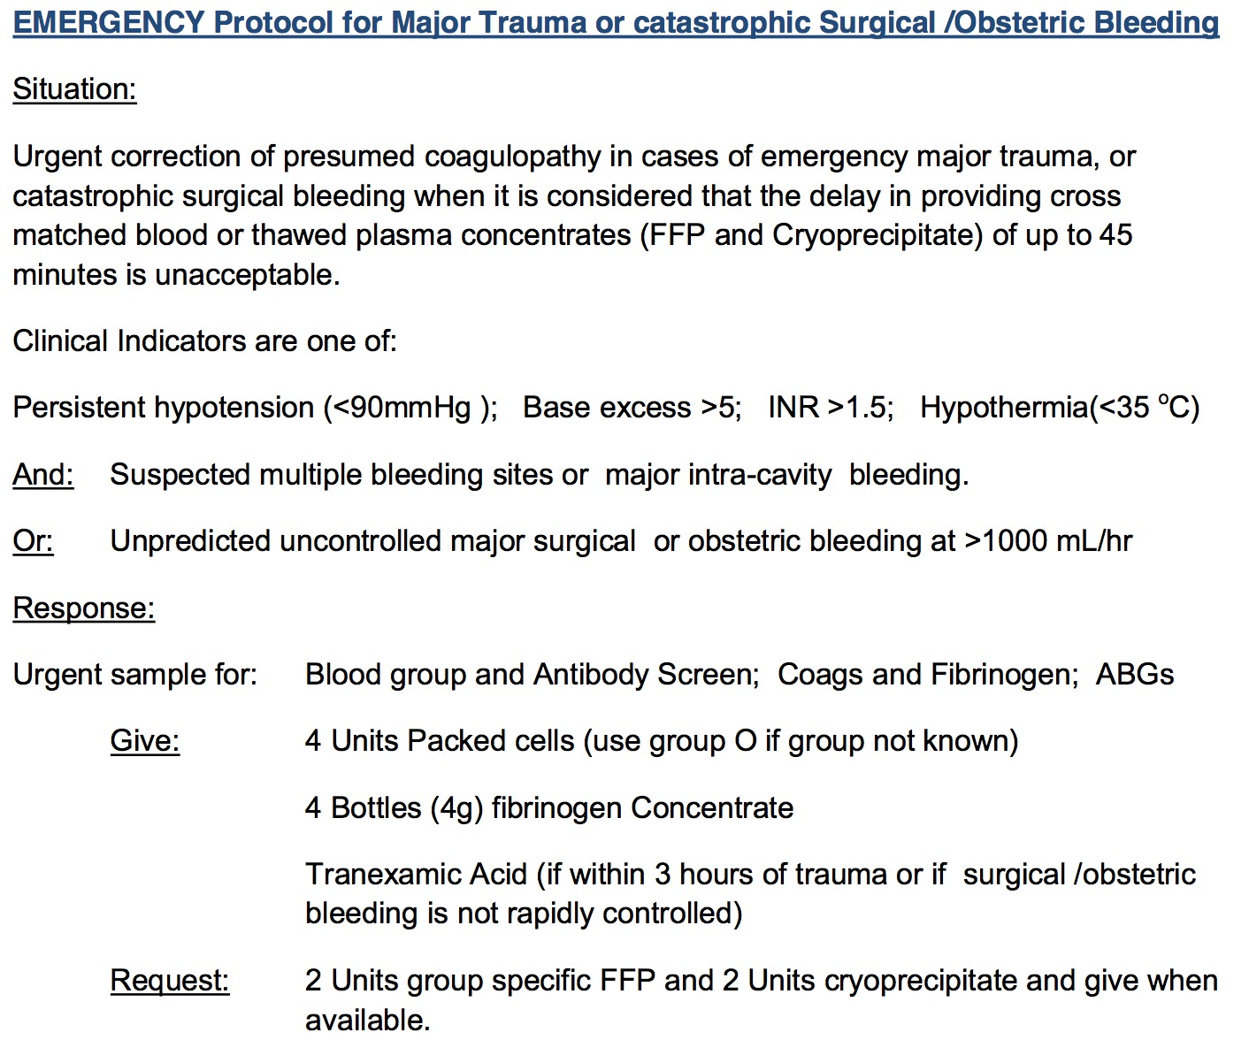
- Blood products RBC:Plts:FFP 1:1:1
- For most in-patients Aim Hb >70 or >90 if IHD
- Reverse coagulopathy: tranexamic acid, vit K, prothrombinex, idarucizumab
- Local measures: manual compression/ kaltostat/ local adrenaline
- Octreotide/ terlipressin/ ceftriaxone

Unexplained Hypotnesion?
