12 Lead ECG interpretation
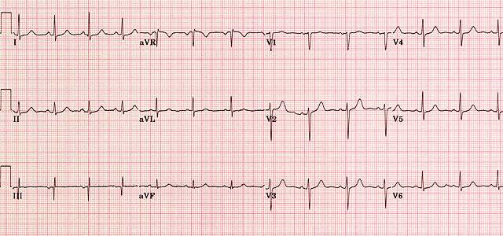

Rule of 4s
4 initial features

- Clinical history
- Rate
- Rhythm
- Axis

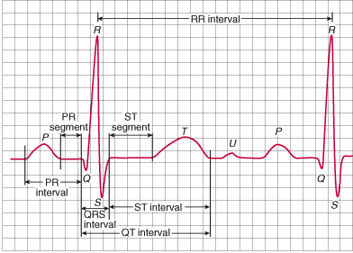
  - I negative- Right axis deviation
  - II and III negative- Left axis deviation
4 waves
- P
  - Present/ P pulmonale/mitrale
- Q
  - Present/ progression/ amplitude
- T
  - Flattening/ inversion/ peaked
- U
  - Present/ absent
4 intervals
- PR
  - 0.12-0.2 seconds (3-5 small squares)
  - Prolonged/ shortened/ depressed
- QRS
  - <0.12 seconds (3 small squares)
- ST
  - Elevation/ depression/ morphology (concave, convex, coved, saddle-back)
- QT
  - Prolonged/ shortened
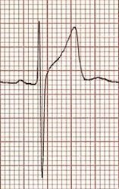
MI localisation
BER
Inferior leads
- II, III, aVF
- Right coronary artery/ Left circumflex
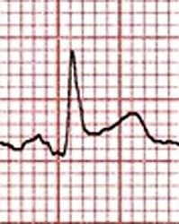
Anterior leads
Pericarditis
- V2, V3, V4
- Left anterior descending
Lateral leads
- I, aVL, V5, V6
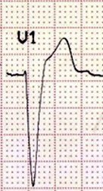
- Left circumflex
LBBB
Posterior
- Suspect especially in inferior
- ST depression V1 and V2
- RCA/ LCx
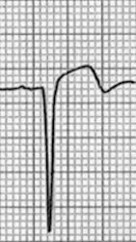
STEMI mimics
LV aneurysm
- Benign early repolarisation
- Pericarditis
- LV aneurysm
- LV hypertrophy
- Ventricular pacing
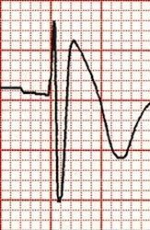
- BBB
- Hyperkalaemia
Brugada
- Raised ICP
- Brugada

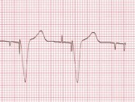
Bundle Branch Blocks
Pacing
Complete/incomplete
Left
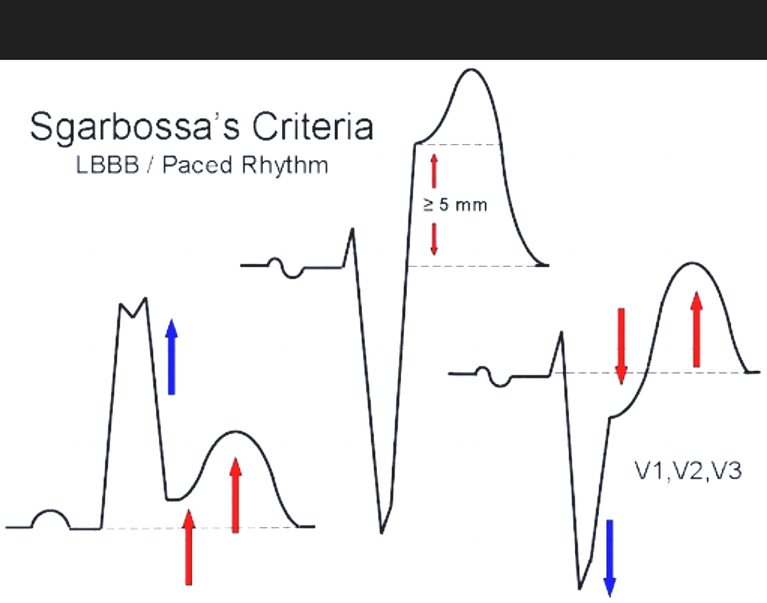
- WiLLiaM
Right
- MoRRoW
Sgarbossa’s Criteria (3 criteria for MI in LBBB)
- Concordant STE >1mm (score 5)
- Concordant STD >1mm (score 3)
- Discordant STE >5mm
Case - https://emergencypedia.com/2013/09/16/sgarbossa-criteria-in-bundle-branch-blocks-and-paced-rhythm

