C.O.A.C.H.E.D.

COACHED – a Mnemonic for Safe Defibrillation – generally used by ALS nurse and in ED
- Continue compressions (I won’t shock you)
- Oxygen away (only required to be removed if on free flowing BVM)
- All else clear
- Charging Defibrillator (200 joules)
- Hands off please
- Evaluate rhythm
- Defibrillate OR Dump Charge
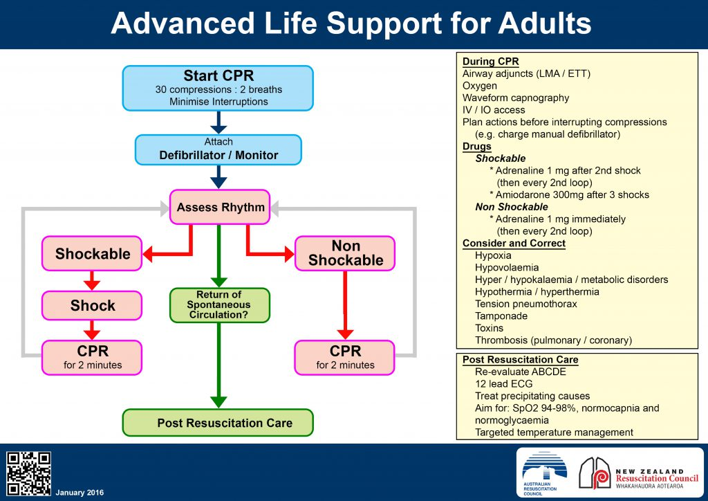
Post- resuscitation care (what to do after a successful resuscitation?)

Airway
- ?need for adjuncts/ intubation (anaesthetics pager 8460)
Breating
- Maintain sats >94%- avoid hypoxia
- ABG
- Avoid hypercapnoea
- Assess differentials- ?PE/ pneumothorax
Circulation
- Maintain BP
  - IV fluids (cold v warn)
  - Vasopressors: metaraminol/ adrenaline
- 12 lead ECG and monitoring
- Assess other circulation problems that may have caused arrest - ?tamponade/ MI/ dissection
D
- Assess GCS and pupils
- Assess differentials ?SAH/ toxins
E
- Temperature ?hypo/hyperthermic
- ?therapeutic temperature management- avoid hyperthermia
F
- IVFs
G
- Maintain normoglycaemia

Management of acute STEMI
- Dual antiplatelets
  - Aspirin 300mg (can give NG/ PR if unable to swallow)
  - Clopidogrel 600mg/ prasugrel 60mg/ ticagrelor 180mg
- Analgesia
  - Morphine/ fentanyl
  - Nitrates: use with caution in inferior STEMI
- Avoid hypoxia and hyperoxia- aim sats 94-98%
- Heparin- consider bolus +/- infusion on cardiology’s advice
- Activate cath lab urgently
- Notify patient/ family of need for cath but leave formal consent for cardiology
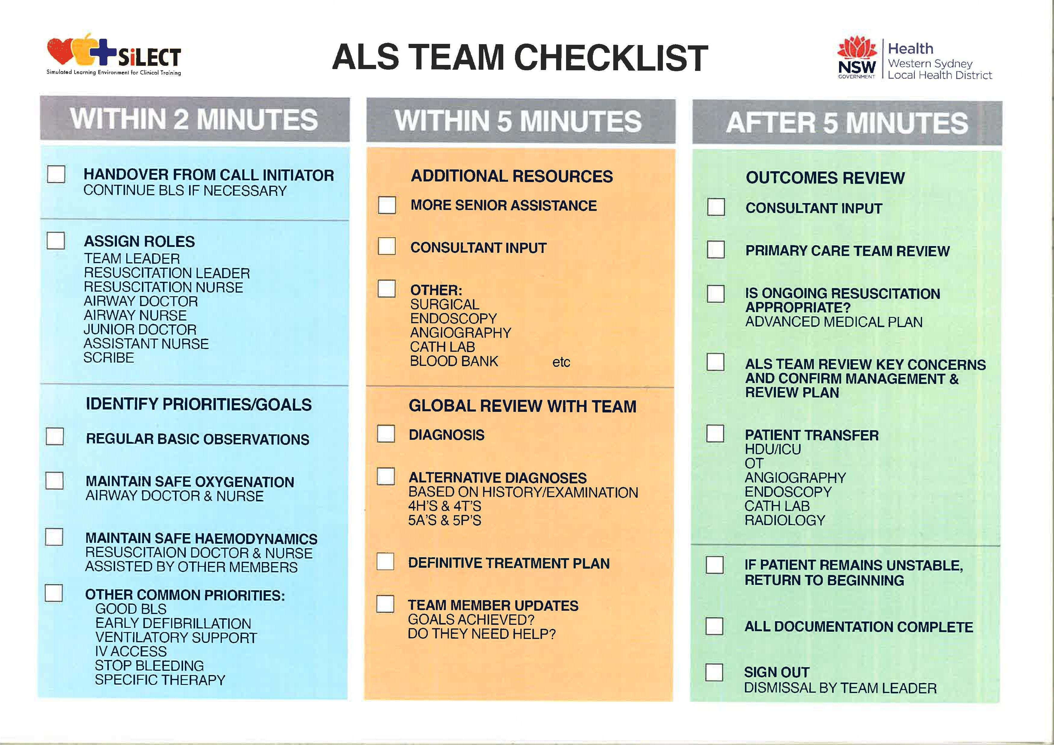
- Time is muscle!

